1. Use the Intermediate Value Theorem to show the there is a zero between 1 and 2 for the function . Explain yourself.
2. Given the function , find function f(-2) two ways.
3. Is  a factor of ? Why or why not?
4. List all possible rational roots for .
5. Find all actual roots for.
6. How many of the roots in #5 were real? What do we know about them?
7. Write a polynomial function of least degree with leading coefficient 1 and the zeroes being 3 (multiplicity 2), 5, and 3-i. DO NOT MULTIPLY YOUR ANSWER!
8. Use synthetic division with the function  to determine if 1 is an upper bound. Explain.
9. Use synthetic division with the function  to determine if -2 is an lower bound. Explain.
10. Find the intervals where the function  is positive and negative. Show all work. Graph it.
11. Find the intervals where the function  is positive and negative. Show all work. Graph it.
12. Find the domain and intercepts for .
13. Be able to find limits from a graph.

For #14-16, find all asymptotes (horizontal, oblique, and vertical) and holes for the following functions:

1. 
2. 

16.

1. 
2. Create a rational function with a hole at x=3, a VA at x=4, and a HA at y=5.

18.

1. Draw a graph whose

* Domain: all real numbers except -3 and 3.
* x-int: (-4,0),(2,0)
* VA: x=-3
* 
* 
* Hole at (3,2)
* HA: y=4
* Positive:
* Negative: 

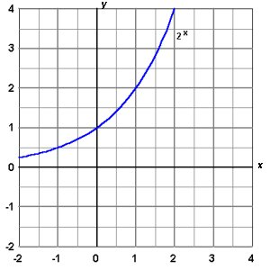

1. Given the exponential function , graph  .
2. Given the exponential function , graph .
3. Find the domain and range for g(x) in #1.
4. Find the domain and range for h(x) in #2.
5. Rewrite the equation in exponential form: .
6. Evaluate 
7. Find 
8. Find log .0000001
9. Combine into a single logarithm: 
10. Find 

For #29-34, solve for x:

1. 
2. 
3. 
4. 
5. Solve 
6. Graph .What is its domain? range? Are there any asymptotes?